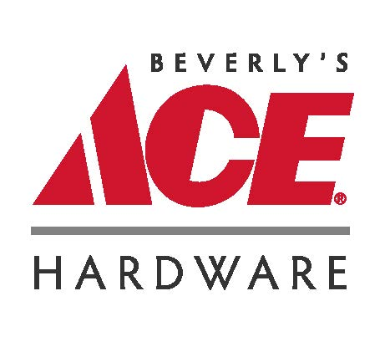
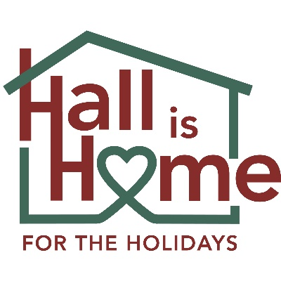

&

Festival of Trees
Hall is Home for the Holidays (HIHH) brings together the efforts and dedication of many
individuals and organizations in our community to provide Christmas gifts and other resources
for children and families impacted by the child welfare system. In 2019, HIHH hosted its first
ever Christmas Celebration for these special children and families at the Gainesville Civic Center. Although COVID put a damper on our plans in 2020 and 2021, thanks to our partnership with Beverly’s Ace Hardware, HIHH is planning an even bigger celebration at the Gainesville Civic Center on Saturday, December 3, 2022.

The Festival of Trees will be an added feature to all the activities** we are planning for the December 3rd Celebration at the Civic Center. HIHH is soliciting sponsors now to provide entry fees that will benefit the HIHH gift giving as well as covering the cost of a special tree decorating kit to be provided by Beverly’s Ace Hardware. The Festival of Trees sponsorship will be $300.00 and qualifies as a tax deductible donation. The sponsored trees will be placed around highly visible areas of the Civic Center (adjacent to and in the Celebration Ballroom) for the December 3rd Christmas Celebration party. Sponsors will be encouraged to put up their trees and place signage near the tree indicating their sponsorship. Sponsors may include: businesses, civic groups, churches and individuals. All donations will be tax deductible less the cost of the tree decorating kit. Hall is Home for Kids fiscal agent, Refined By Fire Ministries, Inc. will provide an end of year receipt to the sponsor.
At the close of the Christmas Celebration, the decorated trees will be given away through a drawing that will include the names of the families in attendance (the family must be present to receive the tree which will be undecorated and placed in an easy to carry box for the family to take home).
For more information contact:
Beth Swenson, Hall is Home Christmas Celebration Coordinator,
bethswensonevents@gmail.com - 770-362-7186

**Additional activities during Celebration Party: arts & crafts, coloring sheets, STEM presentation, face painting, lunch provided, Santa Claus with families taking pictures, Mrs. Claus Sweet Shop and Story Time; Brenau Cheer Team Dances, D-Jay and music.
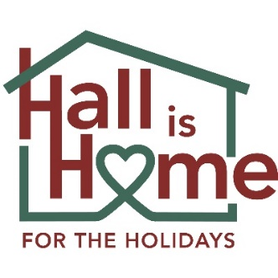

Festival of Trees
Sponsorship Commitment
Hall is Home for the Holidays in partnership with Beverly’s Ace Hardware, will host a Christmas Party Celebration at the Gainesville Civic Center on Saturday, December 3, 2022 from 11:00 a.m. to 1:00 p.m. for Hall County Foster Children and their families.

As a Festival of Trees Sponsor, you will receive:

- A Christmas Tree Kit that includes a 6-foot lighted tree, ornaments, garland and tree topper,

- Signage to be placed by sponsored tree at Christmas Celebration on Saturday, December 3, 2022 at the Gainesville Civic Center,

- Trees will be decorated on Friday, December 2nd. Sponsor can designate representatives to decorate tree at Civic Center or let Hall is Home for the Holidays staff know that you would like our volunteers to decorate for you,

- Trees will be donated to a deserving family at the end of the December 3rd Celebration,

- Sponsorship includes two invitations for sponsor representatives to attend December 3rd Celebration.
Sponsorship Cost: $300.00
Payable by September 15, 2022

Agreed to this ______day of ____________, 2022. ______Will decorate _______HIH Decorate
PLEASE PRINT CLEARLY:
Name:__________________________Signature:_____________________________
Affiliation:____________________________________________________________
Address:_____________________________________________________________
Phone:_________________________ Email:________________________________

